EDA REPORT FOR FEATURE ENGINEERING
Rows: 96,586
Columns: 28

Data Types
Data Type | Count
object | 13
float64 | 8
datetime64[ns] | 4
int64 | 3

Data Quality Scorecard
Column | Type | Missing % | Unique | Unique %
Plant | object | 0.0 | 1 | 0.0
Vendor | object | 0.0 | 213 | 0.22
Name 1 | object | 0.0 | 213 | 0.22
PO Create Date | datetime64[ns] | 0.0 | 3431 | 3.55
Purchasing document | float64 | 100.0 | 0 | 0.0
Item | int64 | 0.0 | 92 | 0.1
Material | object | 0.0 | 3564 | 3.69
Short Text | object | 0.0 | 3439 | 3.56
Profit Center | float64 | 100.0 | 0 | 0.0
Name | float64 | 100.0 | 0 | 0.0
Date Due | datetime64[ns] | 0.0 | 4141 | 4.29
Date Rcvd | datetime64[ns] | 0.27 | 3576 | 3.7
Qty Due | float64 | 0.0 | 2186 | 2.26
Qty Rcvd | float64 | 0.0 | 2184 | 2.26
OTD Band | object | 0.0 | 7 | 0.01
Description | object | 0.0 | 7 | 0.01
Status (Qty) | object | 0.27 | 2 | 0.0
Status (Date) | object | 0.0 | 3 | 0.0
Days Late | object | 0.34 | 441 | 0.46
Net Order Price | float64 | 0.0 | 5998 | 6.21
Purchasing Group | float64 | 100.0 | 0 | 0.0
Purchasing Doc. Type | object | 0.0 | 11 | 0.01
Price unit | int64 | 0.0 | 53 | 0.05
Order unit | object | 0.0 | 10 | 0.01
GR processing time | int64 | 0.0 | 13 | 0.01
Description p. group | float64 | 100.0 | 0 | 0.0
Delivery date | datetime64[ns] | 0.0 | 4103 | 4.25
Currency | object | 0.0 | 3 | 0.0

Missing Value Ranking
Column | Missing %
Profit Center | 100.0
Name | 100.0
Purchasing document | 100.0
Description p. group | 100.0
Purchasing Group | 100.0
Days Late | 0.34
Status (Qty) | 0.27
Date Rcvd | 0.27
PO Create Date | 0.0
Name 1 | 0.0
Vendor | 0.0
Plant | 0.0
Date Due | 0.0
Item | 0.0
Material | 0.0
Short Text | 0.0
Description | 0.0
OTD Band | 0.0
Qty Due | 0.0
Qty Rcvd | 0.0
Net Order Price | 0.0
Status (Date) | 0.0
Price unit | 0.0
Purchasing Doc. Type | 0.0
Order unit | 0.0
GR processing time | 0.0
Delivery date | 0.0
Currency | 0.0

Constant Features
Column
Plant
Purchasing document
Profit Center
Name
Purchasing Group
Description p. group

Near Constant Features
Column | Dominant Value | Frequency %
Plant | 2A32 | 100.0
Purchasing document | nan | 100.0
Profit Center | nan | 100.0
Name | nan | 100.0
Status (Qty) | In Full | 99.66
Purchasing Group | nan | 100.0
Price unit | 1 | 95.74
Description p. group | nan | 100.0
Currency | USD | 99.9

Numeric Feature Summary
Column | Min | Max | Mean | Median | Std
Purchasing document | nan | nan | nan | nan | nan
Item | 1.0 | 2700.0 | 16.6213 | 10.0 | 42.1079
Profit Center | nan | nan | nan | nan | nan
Name | nan | nan | nan | nan | nan
Qty Due | 0.0 | 6521283.5 | 935.2352 | 120.0 | 50822.2358
Qty Rcvd | 0.0 | 6521283.5 | 921.5519 | 120.0 | 50494.5756
Net Order Price | 0.0 | 146192.12 | 251.2376 | 17.29 | 2921.3681
Purchasing Group | nan | nan | nan | nan | nan
Price unit | 0.0 | 50000.0 | 8.2522 | 1.0 | 289.9524
GR processing time | 0.0 | 24.0 | 2.6177 | 2.0 | 1.8198
Description p. group | nan | nan | nan | nan | nan

Outlier Analysis
Column | Outliers | Outlier %
Purchasing document | 0 | 0.0
Item | 12418 | 12.86
Profit Center | 0 | 0.0
Name | 0 | 0.0
Qty Due | 6470 | 6.7
Qty Rcvd | 6460 | 6.69
Net Order Price | 11144 | 11.54
Purchasing Group | 0 | 0.0
Price unit | 4115 | 4.26
GR processing time | 827 | 0.86
Description p. group | 0 | 0.0

Skewed Features
Column | Skewness
Item | 31.43
Qty Due | 96.26
Qty Rcvd | 97.48
Net Order Price | 28.75
Price unit | 125.09

Highly Correlated Features
Feature 1 | Feature 2 | Correlation
Qty Due | Qty Rcvd | 0.998

Categorical Feature: Plant
Value | Count
2A32 | 96586

Categorical Feature: Vendor
Value | Count
V00001 | 13119
V00066 | 8117
V00009 | 7929
V00013 | 7201
V00063 | 5658
V00033 | 5065
V00048 | 3663
V00034 | 3193
V00002 | 2953
V00003 | 2818

Categorical Feature: Name 1
Value | Count
Sabre Technologies Co. | 13119
Granite Solutions Associates | 8117
Jefferson Fasteners Enterprises | 7929
Sabre Manufacturing Group | 7201
Enviro Process Group | 5658
Enviro Distribution & Co. | 5065
Rapid Technologies Ltd. | 3663
Universal Process Inc. | 3193
Hartwell Products Co. | 2953
Falcon Controls LLC | 2818

Categorical Feature: PO Create Date
Value | Count
2012-09-30 | 2488
2021-11-04 | 1038
2012-09-28 | 821
2018-11-26 | 769
2015-12-07 | 746
2018-11-20 | 718
2019-12-04 | 694
2014-12-15 | 626
2019-11-11 | 574
2014-12-12 | 529

Categorical Feature: Material
Value | Count
M01811 | 618
M02238 | 356
M00736 | 355
M01610 | 355
M02632 | 349
M03060 | 338
M01773 | 334
M00237 | 329
M00159 | 321
M00782 | 321

Categorical Feature: Short Text
Value | Count
Spiral Wound Gasket 1-1/8"-7 316SS/Graphite | 618
Ball Valve 2-1/2" 600 WOG Brass | 356
CPVC Pipe 2-1/2" SDR-11 10ft | 355
Pipe Tee 1" Galvanized Threaded | 355
Industrial Component 4553 MFG Grade | 349
Industrial Component 1735 MFG Grade | 338
Steel Tube 3/8"-16 A500 HSS 2x2x3/16 | 334
Sheet Metal Screw #4" Pan Head Zinc | 329
Pipe Tee 1/4"-20 Galvanized Threaded | 321
Cutting Wheel 1" Type 1 A60T | 321

Categorical Feature: Date Due
Value | Count
2022-09-29 | 171
2022-03-30 | 145
2022-08-30 | 140
2021-12-22 | 132
2022-07-28 | 132
2023-08-30 | 130
2022-05-27 | 128
2023-05-30 | 123
2022-02-25 | 123
2023-10-30 | 122

Categorical Feature: Date Rcvd
Value | Count
NaT | 257
2013-05-01 | 131
2017-02-03 | 129
2017-07-05 | 128
2016-01-05 | 125
2024-01-27 | 115
2022-07-26 | 108
2015-03-02 | 106
2012-10-08 | 106
2016-07-05 | 101

Categorical Feature: OTD Band
Value | Count
B | 75356
F | 6323
E | 6088
D | 3772
A | 2531
C | 2184
Z | 332

Categorical Feature: Description
Value | Count
Hit / On Time | 75356
Miss / > 15 Calendar Days | 6323
Miss / 5-15 Calendar Days | 6088
Miss / 2-4 Calendar Days | 3772
Miss / Early | 2531
Miss / 1 Day Late | 2184
Not Delivered | 332

Categorical Feature: Status (Qty)
Value | Count
In Full | 96254
nan | 257
Partial | 75

Categorical Feature: Status (Date)
Value | Count
On Time | 75356
Late | 18699
Early | 2531

Categorical Feature: Days Late
Value | Count
0 | 24696
1- | 16246
2- | 13450
3- | 11128
4- | 7921
1 | 2184
5- | 1915
2 | 1565
3 | 1275
5 | 946

Categorical Feature: Purchasing Doc. Type
Value | Count
ZLTA | 57673
ZPO | 18540
ZTOP | 9815
ZSTO | 7908
ZOP | 1040
ZRWK | 935
ZNPO | 670
ZPSO | 2
ZCAP | 1
ZAMS | 1

Categorical Feature: Order unit
Value | Count
EA | 91300
FT | 4039
GAL | 339
OT | 322
G | 265
LB | 193
FT3 | 78
FT2 | 47
HCF | 2
OZ | 1

Categorical Feature: Delivery date
Value | Count
2022-09-29 | 170
2022-03-30 | 143
2022-08-30 | 140
2021-12-22 | 133
2023-08-30 | 130
2022-07-28 | 130
2022-05-27 | 127
2022-12-22 | 125
2023-05-30 | 123
2022-02-25 | 122

Categorical Feature: Currency
Value | Count
USD | 96486
GBP | 98
SEK | 2

EDA REPORT FOR FEATURE ENGINEERING

Control Charts

Control Chart: Item
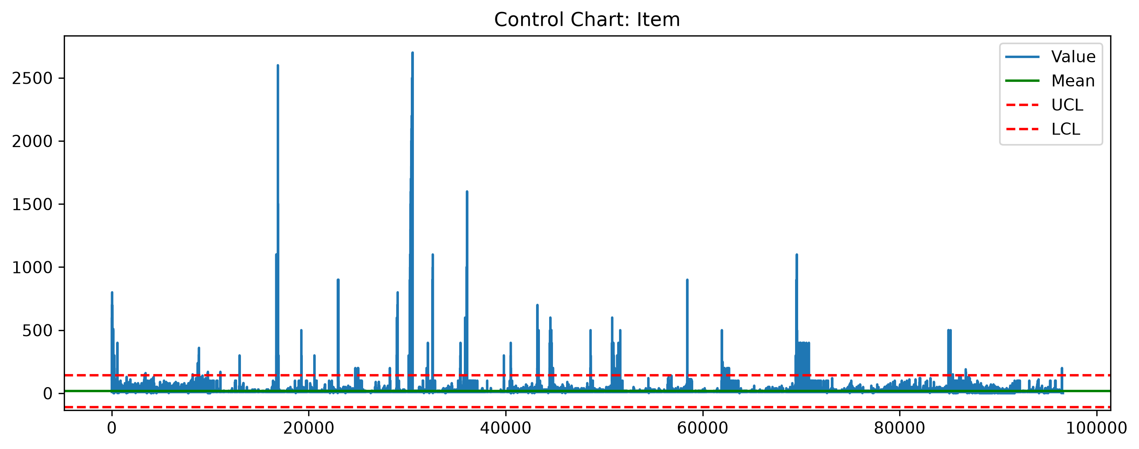

Control Chart: Qty Due
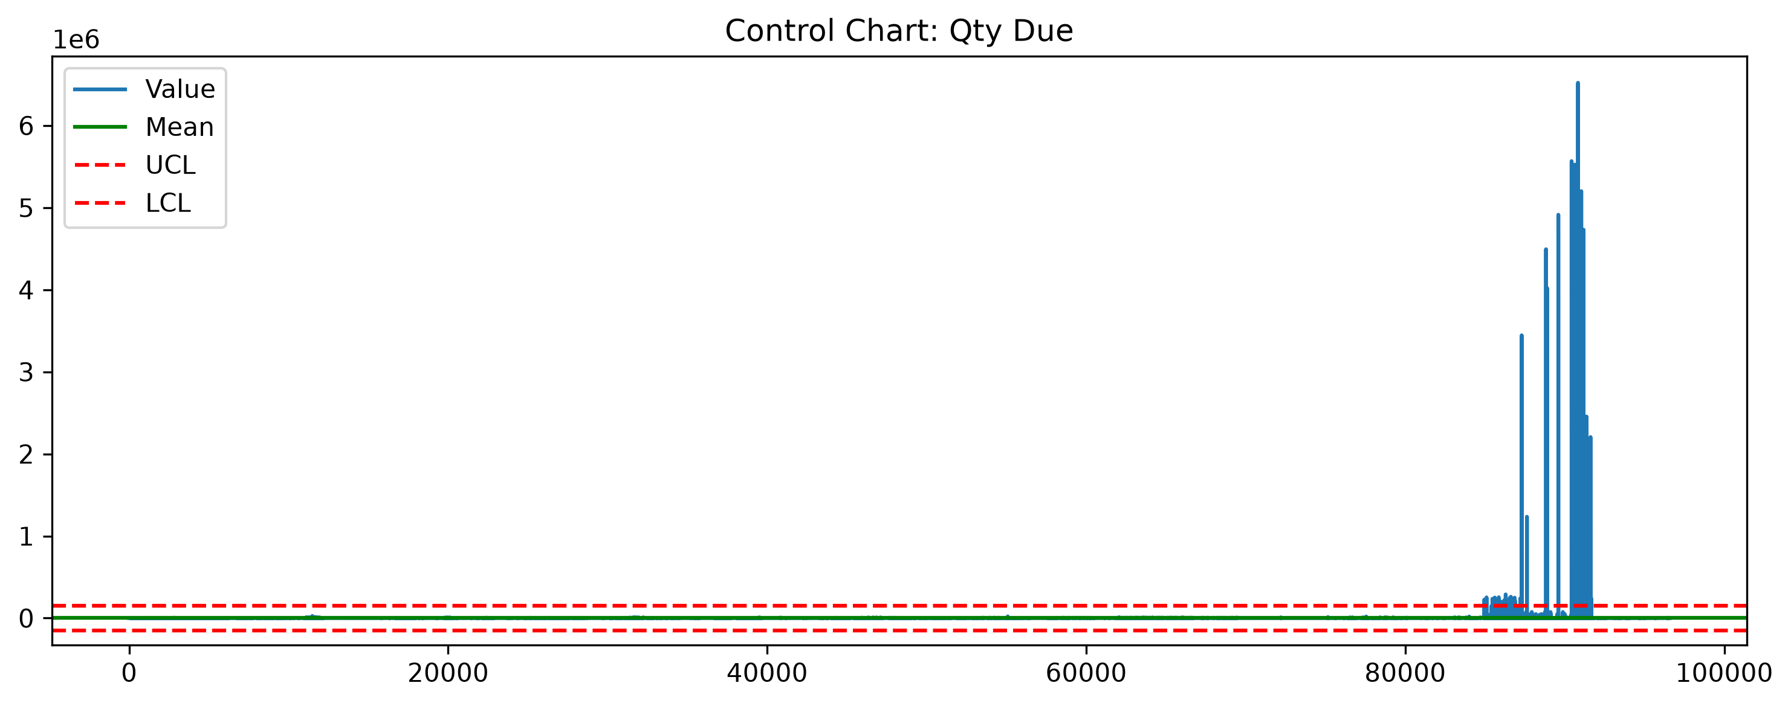

Control Chart: Qty Rcvd
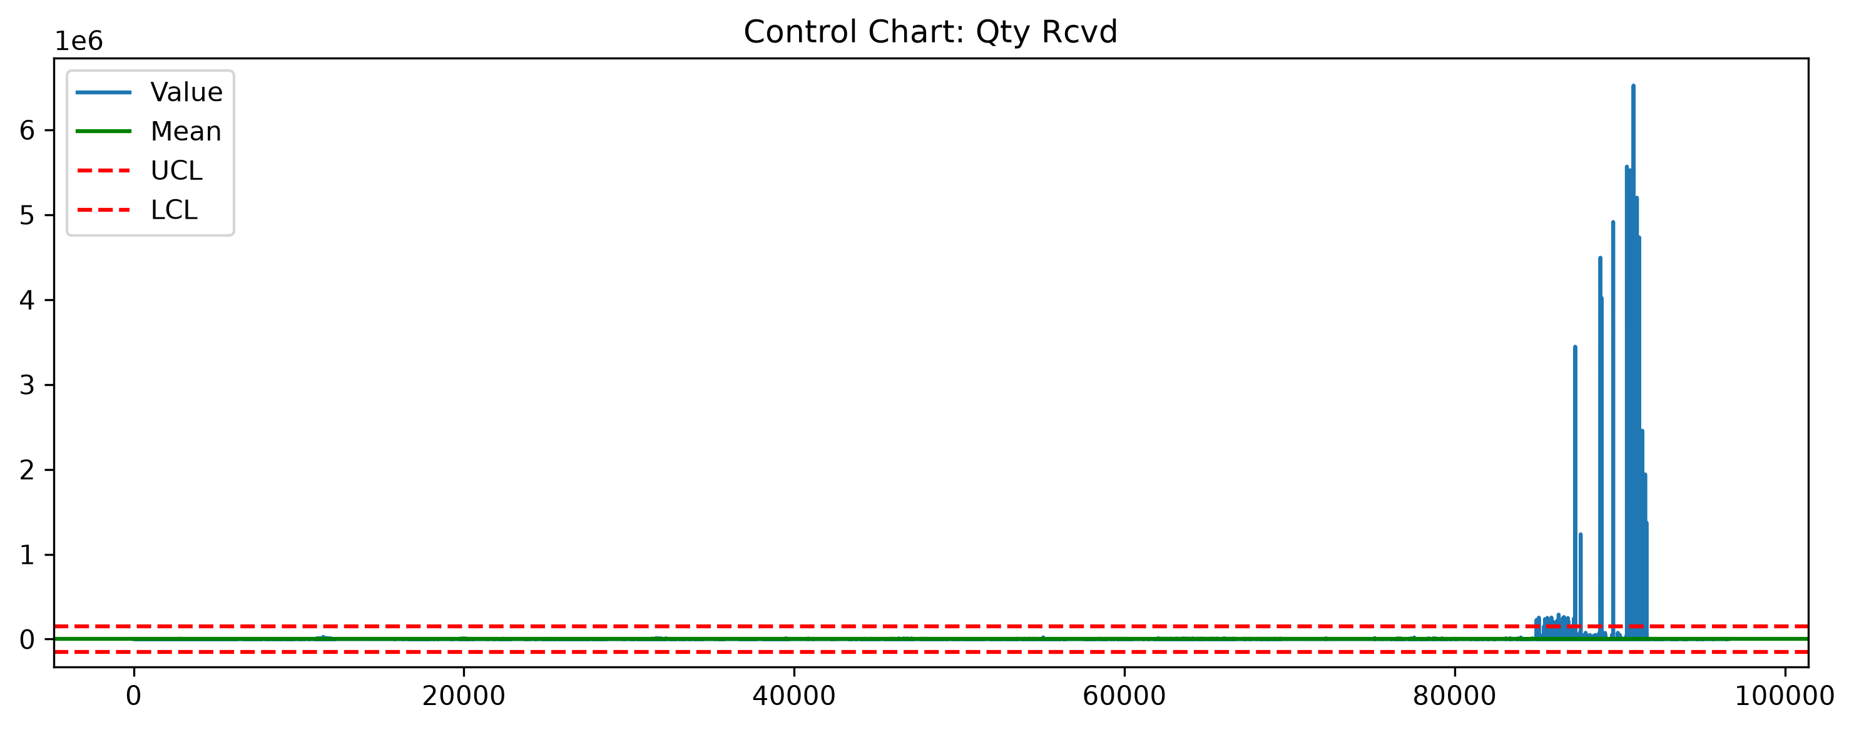

Control Chart: Net Order Price
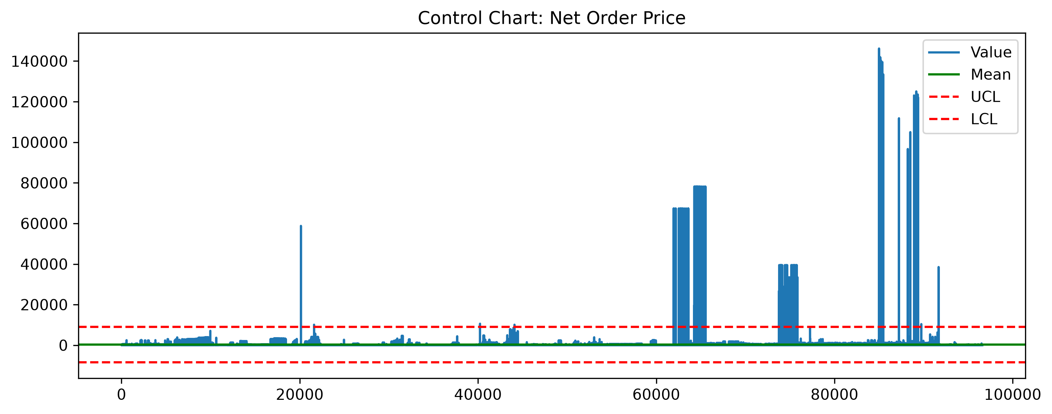

Control Chart: Price unit
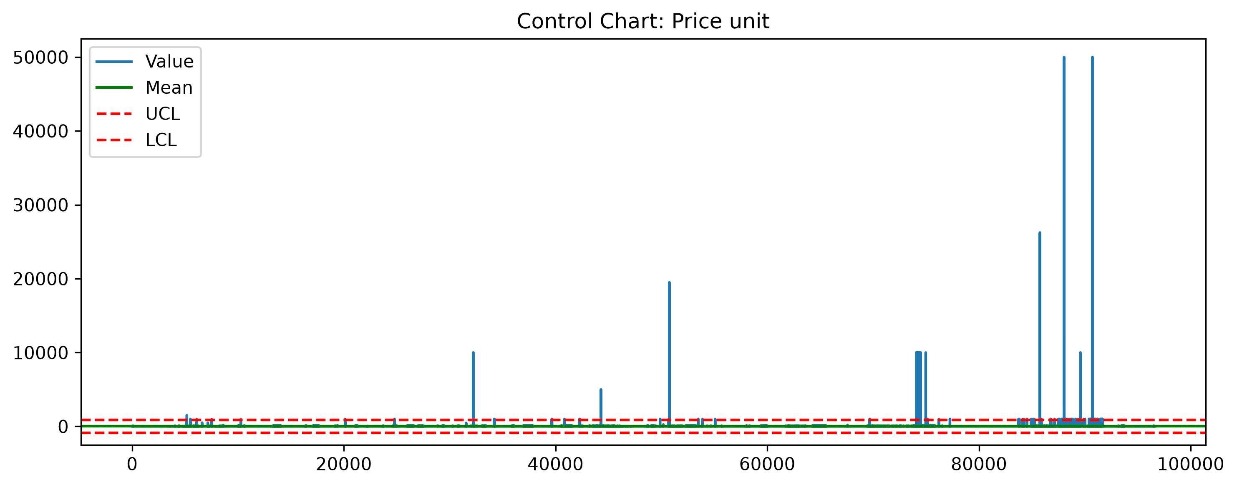

Control Chart: GR processing time
